My Child is Autistic … What Does this Mean?
Children’s Disability Network Teams Carlow, Kilkenny & Thomastown


Autism and Neurodiversity: Autism is a form of neurodiversity. Previously it was thought that there was one type of brain, however we now know that just like in nature where you have “biodiversity”, in humans we have “neurodiversity”, which means that there are many different types of brains called neurotypes.
Autism is a neurotype, just like someone who has a brain that aligns with ADHD or Dyslexia or Dyspraxia. These are all different neurotypes. Different neurotypes experience the world in different but equally valid ways; for autistic people, these differences are seen in terms of communication and social interaction preferences, as well as different ways of experiencing sensory information.
Autism arises from differences in the development of the brain that occur before birth. It has a strong genetic basis but the genetics of autism are complex and not yet fully understood. What we do know is that autism does not arise from anything the parent has done wrong either during pregnancy or after their child is born.
Autism is symbolised by the use of a rainbow coloured infinity symbol, which represents the diversity of autism as well as the greater neurodiversity movement.

Language: There are different types of language used in relation to autism. The preference of the autistic community is to use identify-first language i.e. “autistic person”, “autistic adult”, “autistic community” and this is the language which is commonly used. It is important however to check with individuals what their preferences are and to follow their lead as some people (including children and teens) might prefer person-first language (“person with autism”).

Core Characteristics of autism: Formal identification of autism looks to see if a person is showing significant differences/ clear preferences in each of the following areas:
- Social Communication
- Attention Allocation
- Sensory Processing
- “Stimming” behaviours

Social Communication: This is how a person communicates/ interacts with others. An autistic child/young person shows differences in their social communication preferences. They might:

  - Prefer not to look at others while talking
  - Understand language in a literal way, e.g. it’s raining cats and dogs
  - Find it difficult to interpret facial expression or body language
  - Find it hard to “read others”.
  - May not see the point in or value of “small talk”.
  - Place a high value on honesty.
  - Be happy and content engaging in their own preferred activities
  - Be happy and content not to interact with others or to interact only a little with others and in certain conditions
  - Prefer to follow particular routines to help make the world seem more predictable and less scary.
  - Be very anxious about situations where there are certain social expectations.
  - Respond to others in a different way.
  - Have good language skills or not use language at all to communicate.
  - Find it hard to understand the “unwritten” social rules/expectations within society. These “rules” can make the world seem very unpredictable and confusing.
  - Communicate using echolalia if they use verbal communication, (repeating what others have said or phrases from TV, etc.)
  - Need time alone if overwhelmed by being around others.
  - Form friendships and relationships with others in different ways, e.g. meeting up only once every few months out of school as opposed to every week, play alongside each other doing the same activity.
- Find abstract/vague concepts or sarcasm/humour difficult to understand.
- Need extra time to process information/answer questions.

Attention Allocation:
- Neurotypical (non-autistic) people spread their attention out to lots of things, autistic people can often focus on one thing to the exclusion of everything else. Focusing attention on one thing intensely is known as monotropism.
- Monotropism can be a great skill, but also can interfere with functioning in other areas, e.g. eating, wider learning, etc.

Sensory Processing:

- Different way of experiencing sensory information.
- Can be disabling if a person is in an environment that does not match their sensory experience or needs.
- Helpful to recognise the sensory experience that is happening.
- We often only hear about difficulties, e.g. loud noises, textures, etc.
- There are also positive aspects to sensory processing e.g. seeing beauty in a light beam or gaining intense pleasure from a sensory experience.
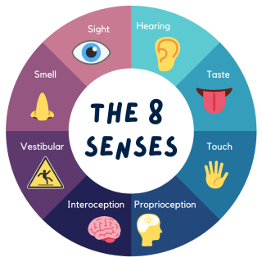

Stimming Behaviour:
- “Stimming” – another word for self-stimulatory behaviour; repetition of physical movements, sounds, words, objects. Examples: hand flapping, pacing, rocking your body, finger tapping, spinning, etc.
- Important to remember that everybody “stims” not just autistic people. Biting nails, playing with hair, tapping a pen could all be considered examples of stimming.
- Autistic people have much less control over stimming than neurotypical (non-autistic) individuals.
- Stimming is a protective response to over-stimulation.
- Stimming helps autistic children to:
  - Block excess sensory inputs when overwhelmed.
  - Reduce the overall sensation of pain (although some stims can themselves cause pain).
  - Get extra sensory input when there is under stimulation.
  - Manage emotions that might be intense or hurtful to a child.
  - Soothe themselves when distressed.
- Preventing stimming causes harm (unless the person is actively hurting themselves). It is highly stressful for the person not to be allowed to stim and increases anxiety.
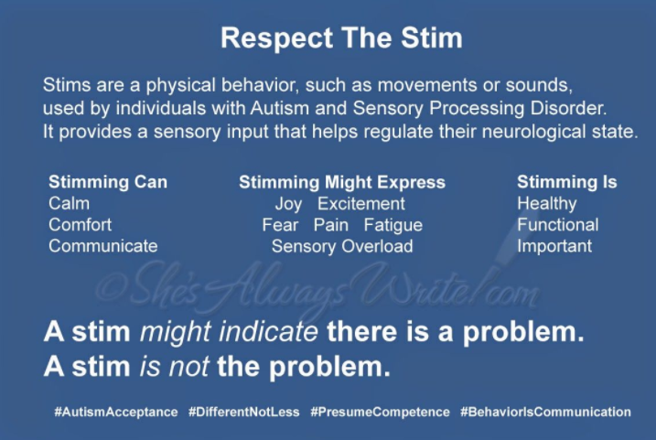

Autistic Girls and Women:
There is growing knowledge and understanding about the experiences of autistic girls and women; it is now commonly understood that the experiences of autistic females differs to that of autistic males. This difference in experience has meant that autistic girls and women are often diagnosed at a later age and/or misdiagnosed. Research previously estimated that males were four times more likely to be formally identified as autistic than females; we know now that this ratio is no longer accurate. The following characteristics tend to be more evident in autistic girls and women:
- A tendency towards shyness
- More likely to imitate the social behaviour of their peers
- Strong creative skills
- Greater desire for friendships
- Less likely to show externalising behaviours
- Greater likelihood of having very strong interests
- Tendency to enjoy arranging toys/items
- Greater levels of stress evident in the home setting than in the school setting

Myths:
The following are myths about autism:
- “Everyone is a bit autistic”
- “Autism is a mental health condition”
- “Autism mainly affects young children”
- “Autistic people don’t feel empathy”
- “All Autistic people have a learning disability”
- “All Autistic people have special skills like Rainman/savants”
- “You can tell someone is autistic by looking at them”
- “Autistic people like to be on their own/they’re anti-social”
- “Autistic people always have other conditions”
- “Autism can be cured”
None of these statements are true but their continued use can cause harm and upset.

Facts about Autism:
Fact 1: Current estimates
  - Approximately 1 in every 65 people is autistic. But, we know there are many undiagnosed autistic people
  - Autistic people are unique and varied, in many professions, across ethnicities, across cultures.
  - There are autistic people achieving in all areas of society – doctors, teachers, journalists, lecturers, engineers, parents, students.

Fact 2: Autism is not a line but rather a constellation

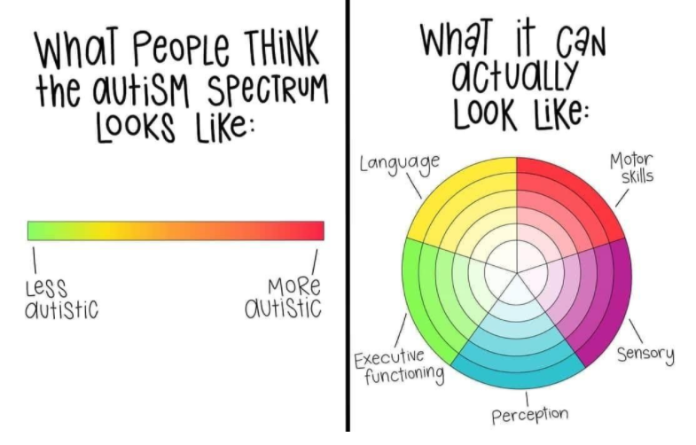
Previously, terms such as ‘high-functioning’/’low functioning’ were used as a descriptor to indicate the level of support which a person might benefit from. We know now that these terms are unhelpful and can be misunderstood; the term ‘high functioning’ implies that a person does not have many support needs whilst the term ‘low-functioning’ ignores the range of strengths that a person has across multiple areas. Research shows that these terms have no clinical accuracy and should not be used. A much more helpful approach is to consider the whole person i.e. what are their communicative preferences, what are their sensory processing needs, what kind of supports do they find beneficial, what are their strengths etc. rather than using labels relating to functioning. It is also important to note that people’s preferences can change on a regular basis, subject to many different factors such as their sensory environment, the demands of the day etc.
Please see Appendix 1 ‘Understanding the Spectrum’ by Rebecca Burgess for a visual explanation.

Fact 3: Your child has huge potential
- Society benefits from having autistic people in the workplace as different types of neurology bring different ways of thinking. Autistic people work in all industries –data management, medicine, academia, law, engineering, journalism, IT, etc.
- Strengths associated with autism include:
  - Attention to detail
  - Deep focus (monotropism)
  - Observational skills
  - The ability to absorb and retain facts
  - Well-developed visual skills
  - In-depth knowledge relating to particular topics and interests
  - A tendency to adopt a methodical approach as well as a willingness to use novel approaches
  - Creativity
  - Tenacity and resilience
  - Greater acceptance of others
  - Integrity
Fact 4: Autism is associated with other conditions
Common co-occurring conditions include, but are not limited to:

- Attention Deficit Hyperactivity Disorder (ADHD)
- Dyslexia/ Dyscalculia
- Dyspraxia/ DCD
- Epilepsy
- General Learning Difficulties
- Apraxia
- Ehlers-Danlos syndrome
- Down syndrome
- Fragile X
- Anxiety
- Mental Health needs
The presence of a co-occurring condition(s) can create additional challenges for an autistic child/young person. In the event that your child/young person has been diagnosed with a co-occurring condition, it is important that they receive appropriate support for both. This might mean liaising with different members of your child/young person’s team or attending a clinician/service that isn’t connected to your child’s team.
Fact 5: The greatest source of information about autism is the autistic community
There are multiple sources for hearing autistic people:
- www.autloud.ie – Irish autistic adults who blog about their experiences, ideas, projects, supports, advocacy etc.
- Twitter – find information using the hashtag #AskingAutistics
- Youtube (Yo Samdy Sam and Agony Autie are autistic vloggers who provide authentic and informative videos relating to Autism and neurodiversity)
- Further links on AsIAm website www.asiam.ie
There are Irish and international autistic advocates and role models in a range of different arenas. Well known autistic role models include actors such as Daryl Hannah, Jordanne Jones, Talia Grant, Wentworth Miller and Anthony Hopkins, writers such as Naoise Dolan, environmental campaigners such as Dara McAnulty and Greta Thunberg and comedians like Hannah Gadsby.

Further Reading:
There are a range of excellent resources for parents/ caregivers and for young people themselves. The following books all adopt a neuroaffirmative approach:
- Uniquely Human: A Different Way of Seeing Autism” by Barry M. Prizant and Tom Fields-Meyer (2019)
- “Autism: How to Raise a Happy Autistic Child” by Jessie Hewitson (2018)
- “Autism and Asperger Syndrome in Childhood: For Parents and Carers of the Newly Diagnosed” by Luke Beardon (2019)
- Loud Hands: Autistic People, Speaking” by Julia Bascom (2012)
- “Born on a Blue Day” by Daniel Tammet (2007)
- “The Reason I Jump: One Boy’s Voice From the Silence of Autism” by Naoki Higashida (2014)
- “Neurotribes: The Legacy of Autism and How to Think Smarter About People Who Think Differently” by Steve Silberman (2017)
- “The Guide to Good Mental Health on the Autism Spectrum” by Jeanette Purkis, Dr Emma Goodall and Dr Jane Nugent (2016)

The following websites are also reliable sources of up-to-date, research-based information about autism and neurodivergence:
- NeuroClastic: The Autism Spectrum According to Autistic People. Autism 101: Resources from the Autistic Community https://neuroclastic.com/2020/08/06/autism-101-resources-from-the-autistic-community/
- Thinking person’s guide to Neurodiversity: http://www.thinkingautismguide.com/p/so-youre-doing-story-about.html
- www.autisticslt.com

Appendix 1: ‘Understanding the Spectrum’ by Rebecca Burgess (www.theartofautism.com)

Acknowledgement to Tara O’Donnell Killen of “Thriving Autistic” and Davida Hartman of “The Children’s Clinic” and “The Adult Autism Practice” for their input on these facts

